**DELHI TECHNOLOGICAL UNIVERSITY**

**DEPARTMENT OF**

**COMPUTER SCENCE ENGINEERING**



**Assignment 3**

**CO 301 Software Engineering**

**SUBMITTED BY:**

Ayush Tandon

2K22/CO/133

**Assignment 3**

Draw use case diagram for different domains, like library system, banking systems, hospital management systems and hotel management system.

Use case diagrams provide a high-level overview of the main functionalities and user interactions in each of the systems you mentioned: library, banking, hospital and hotel management. They can be useful for understanding the core features and user roles in each system.

**Library System Use Case Diagram**

This diagram shows the main actors and use cases in a library system. The actors are:

1. Librarian
2. Member

The use cases include:

1. Manage Books: Add, remove, and update book inventory
2. Issue Books: Lend books to library members
3. Return Books: Process book returns from members
4. Search Books: Find books by title, author, or genre
5. Manage Members: Register new members and update accounts

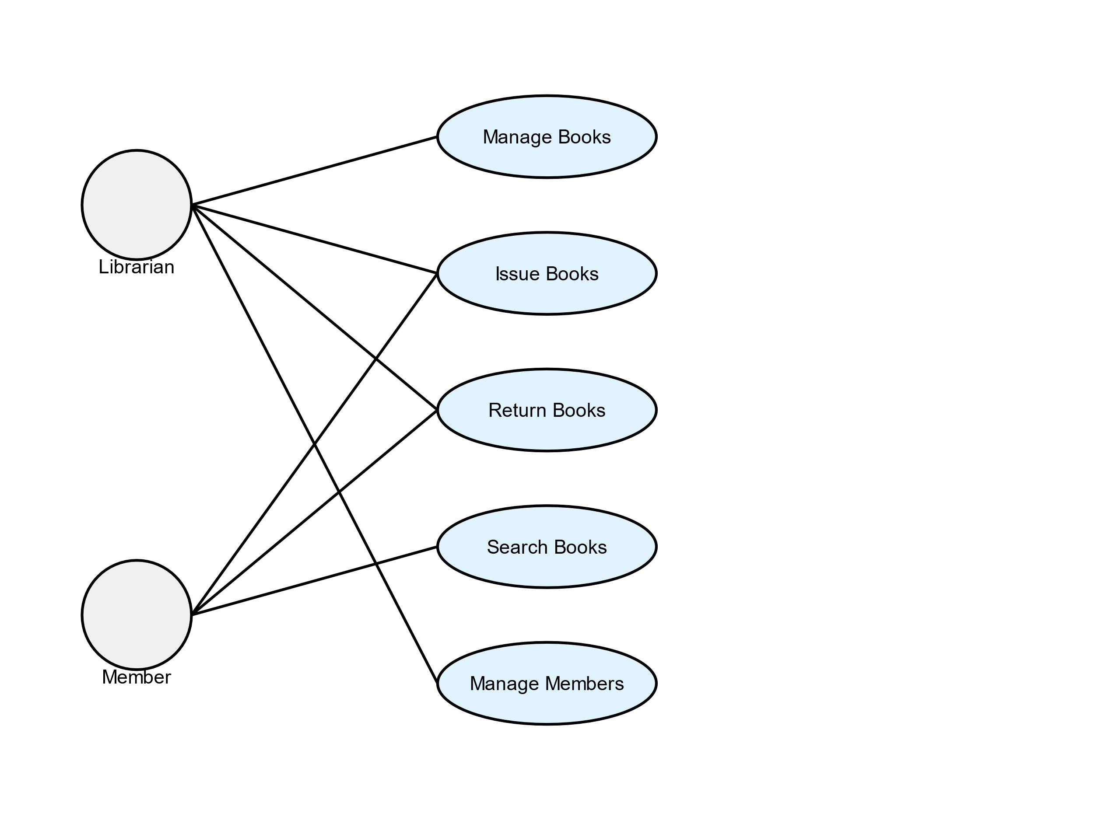

**Banking System Use Case Diagram**

This diagram illustrates the main actors and use cases in a banking system. The actors are:

1. Customer
2. Bank Teller

The use cases include:

1. Open Account: Create new customer accounts
2. Deposit Money: Add funds to customer accounts
3. Withdraw Money: Remove funds from customer accounts
4. Transfer Money: Move funds between accounts or banks
5. Check Balance: View current account balance

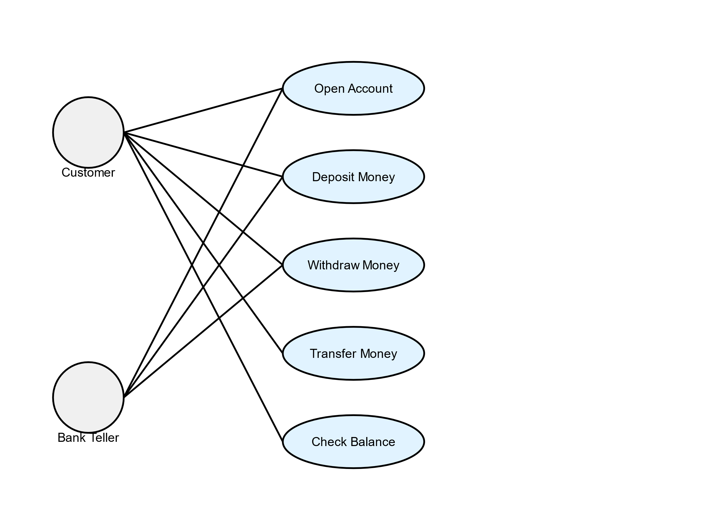

**Hospital Management System Use Case Diagram**

This diagram shows the main actors and use cases in a hospital management system. The actors are:

1. Patient
2. Doctor
3. Admin

The use cases include:

1. Register Patient: Add new patients to the system
2. Schedule Appointment: Book patient visits with doctors
3. Diagnose Patient: Record medical examinations and findings
4. Prescribe Medicine: Issue and track patient prescriptions
5. Manage Staff: Oversee hospital personnel and schedules

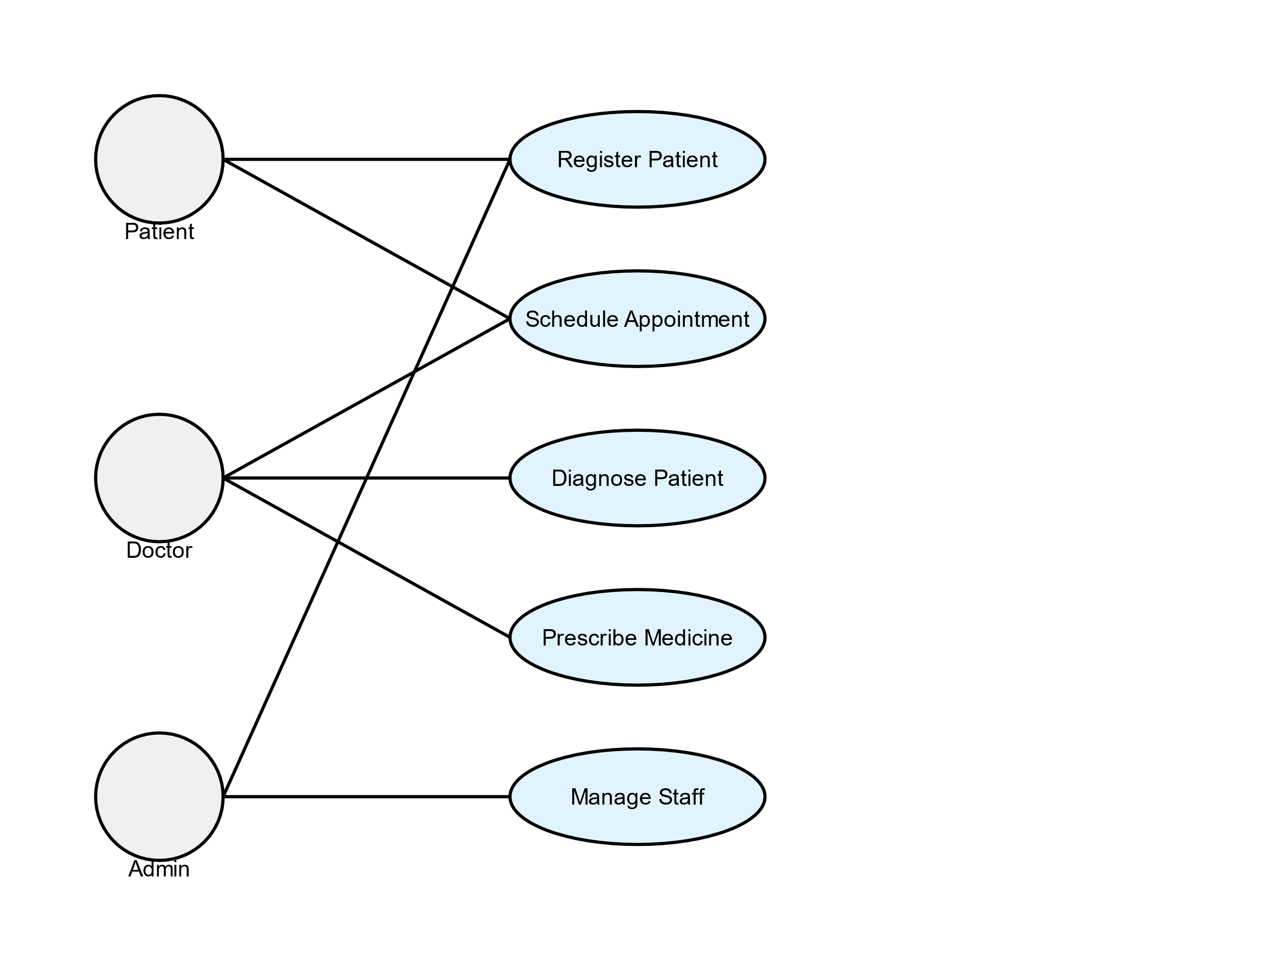

**Hotel Management System Use Case Diagram**

This diagram illustrates the main actors and use cases in a hotel management system. The actors are:

1. Guest
2. Receptionist
3. Manager

The use cases include:

1. Make Reservation: Book rooms for future stays
2. Check-in: Process guest arrivals and room assignments
3. Check-out: Finalize guest stays and process payments
4. Room Service: Manage in-room dining and amenities
5. Manage Staff: Oversee hotel personnel and schedules

